Project Initialization and Planning Phase

Date | June 2024
Team ID | Team-739859
Project Name | Auto Insurance Fraud Detection Using Machine Learning
Maximum Marks | 3 Marks

Define Problem Statements(Insurance Fraud Analysis Template):
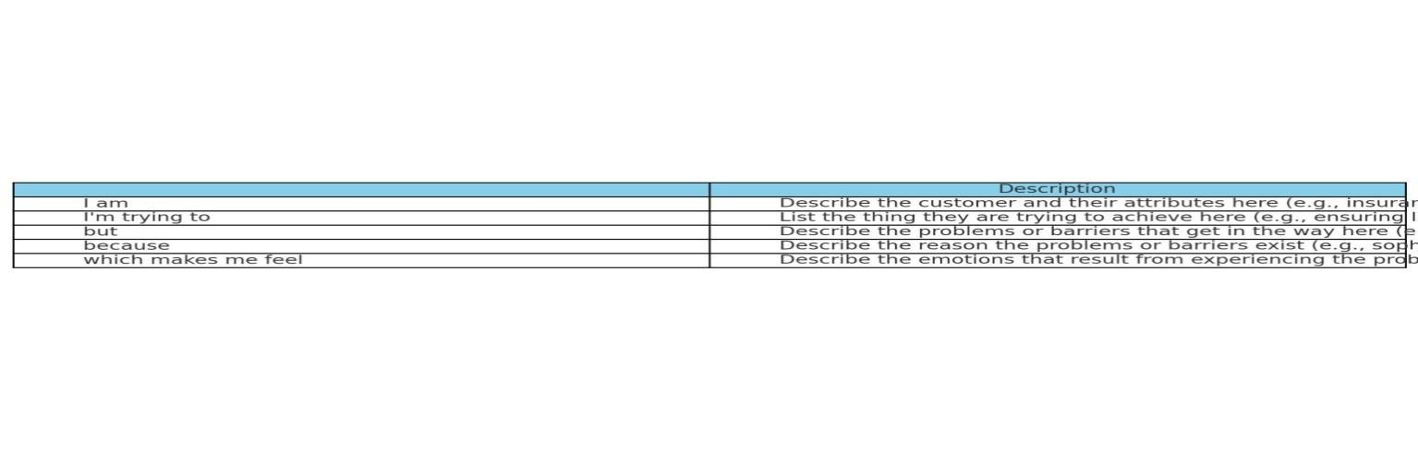
Create a problem statement to understand and effectively address the complexities of identifying and preventing fraudulent activities in auto insurance claims is crucial for ensuring fairness and trust among policyholders. Developing a robust solution that enhances fraud detection capabilities and streamlines the claims process is essential to meet the needs and expectations of insurance customers.
Reference: https://www.canva.com/design/DAGK7T6bAQs/iMnF98-TYsfrLtpFOTJ-Sg/view?utm_content=DAGK7T6bAQs&utm_campaign=designshare&utm_medium=link&utm_source=editor
Example:
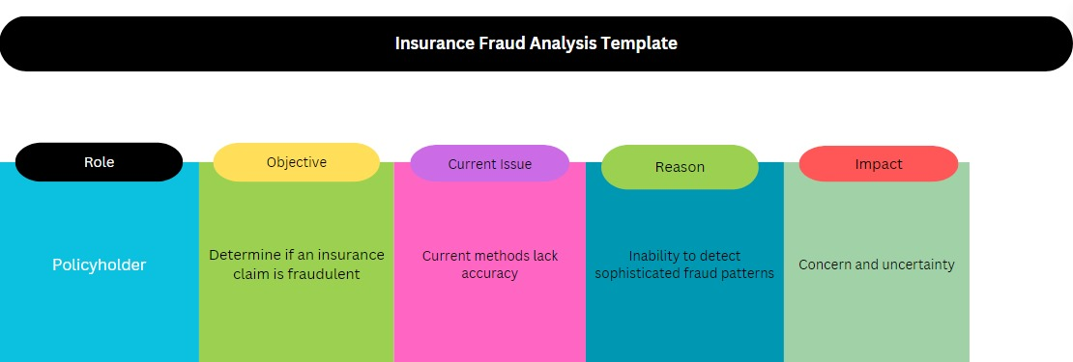

Problem  Statement (PS) | Role | Objective | Current Issue | Reason | Impact
PS-1 | Policyholder | Determine if an insurance claim is fraudulent | Current methods lack accuracy | Inability to detect sophisticated fraud patterns | Concern and uncertainty
PS-2 | Insurance Company | Identify and prevent fraudulent insurance claims | Existing systems miss subtle fraud signals | Limited adaptive learning and real-time monitoring | Risk of financial losses

